**Week 2 Module 4.2 Assignment High/Low Temperatures**

Juan Macias Vasquez

Bellevue University

CSD325-H323 Advanced Python (2255-DD)

**Jack Lusby**

June 15th, 2025

Module 4.2 Assignment: High/Low Temperatures

Results Document

First Flowchart of original Program

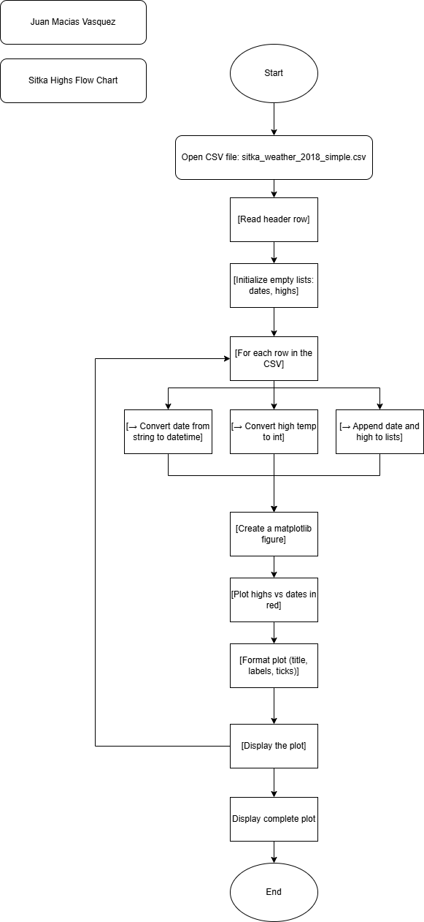

**Changes to the Program**

Changed the name to sitka_high_low_JCMV to have my initials at the end

Created User Menu:

* Added a while True loop to present a menu to the user:

markdown

1. Show HIGH temperatures

2. Show LOW temperatures

3. Exit

Made the plotting based on user choice:

* If user selects 1 → plot high temperatures in red.
* If user selects 2 → plot low temperatures in blue.
* If user selects 3 → exit the program gracefully with a goodbye message.

Added a message if the user picks 3 to leave

Added Input Validation: To make sure the input is correct

* Checks if the user input is one of the expected choices (1, 2, or 3).
* Displays an error message for invalid input like a different number or a letter.

Added the Low Temperature Data:

* Modified the CSV reading loop to also extract low temperatures from column 6 (row[6]), in addition to highs (row[5]).

Reused matplotlib code inside conditional branches to show either highs or lows.

I was did have a lot of issues adding Matplotlib for a whole day but fixed it after needing to add a new path in windows so that python had access to the modules.

**New Code used**

# Juan Macias Vasquez

# Date 06/15/2025

# Module 4.2

# sitka_high_low_JCMV

import csv

from datetime import datetime

import matplotlib.pyplot as plt

import sys

# Load data from CSV

filename = 'sitka_weather_2018_simple.csv'

dates, highs, lows = [], [], []

with open(filename) as f:

reader = csv.reader(f)

header_row = next(reader)

for row in reader:

try:

current_date = datetime.strptime(row[2], '%Y-%m-%d')

high = int(row[5])

low = int(row[6])

except ValueError:

# Skip missing or invalid data

continue

dates.append(current_date)

highs.append(high)

lows.append(low)

# Menu loop for returning to see other graph or quiting

while True:

print("\nTemperature Viewer")

print("1. Show HIGH temperatures")

print("2. Show LOW temperatures")

print("3. Exit")

choice = input("Enter your choice (1-3): ")

if choice == '1':

plt.figure()

plt.plot(dates, highs, c='red')

plt.title("Daily High Temperatures - 2018", fontsize=20)

plt.xlabel('', fontsize=14)

plt.ylabel("Temperature (F)", fontsize=14)

plt.tick_params(axis='both', labelsize=12)

plt.gcf().autofmt_xdate()

plt.show()

elif choice == '2':

plt.figure()

plt.plot(dates, lows, c='blue')

plt.title("Daily Low Temperatures - 2018", fontsize=20)

plt.xlabel('', fontsize=14)

plt.ylabel("Temperature (F)", fontsize=14)

plt.tick_params(axis='both', labelsize=12)

plt.gcf().autofmt_xdate()

plt.show()

elif choice == '3':

print("Exiting the program. Goodbye!")

sys.exit()

else:# error if the user didnt put a correct number

print("Invalid choice. Please enter 1, 2, or 3.")

**Pictures of Code Running**

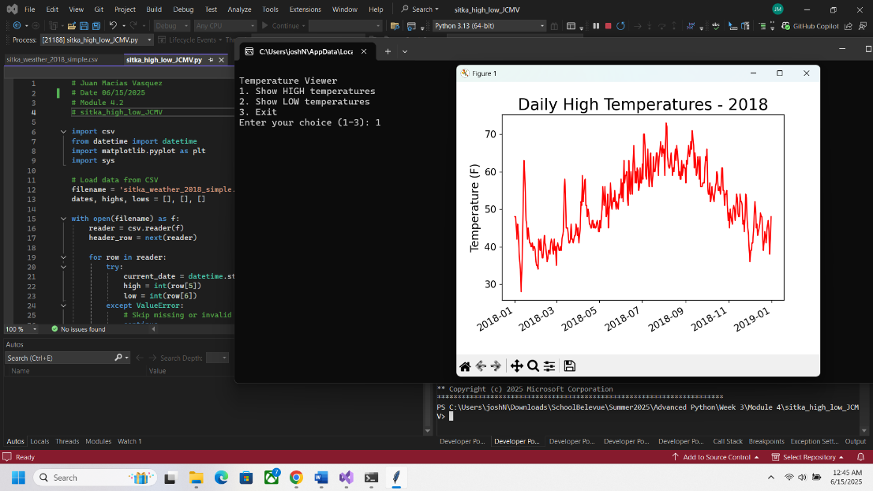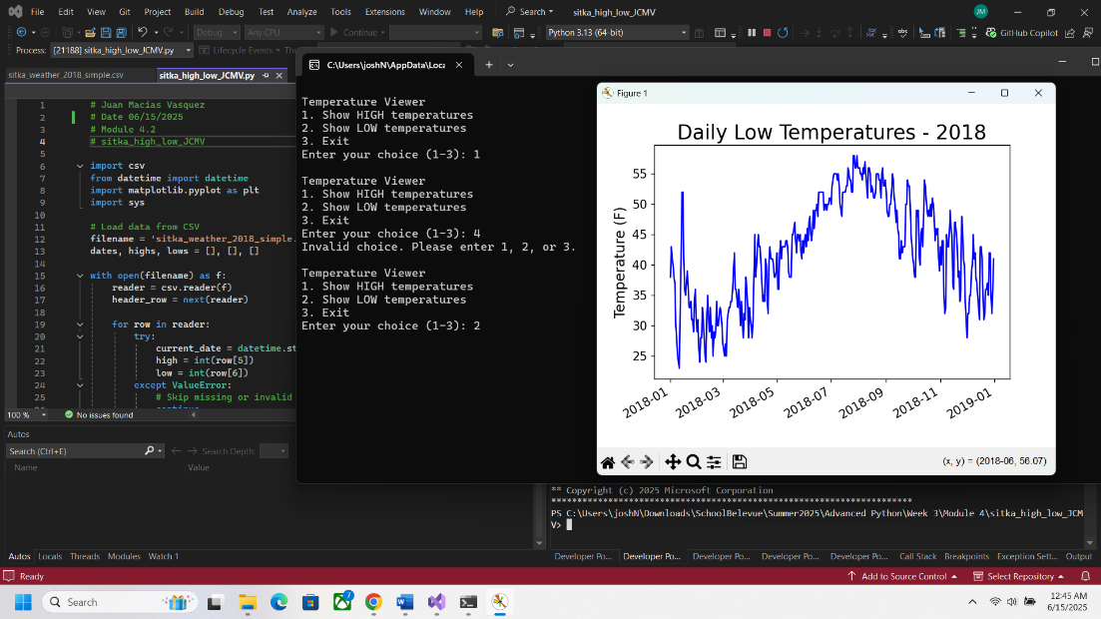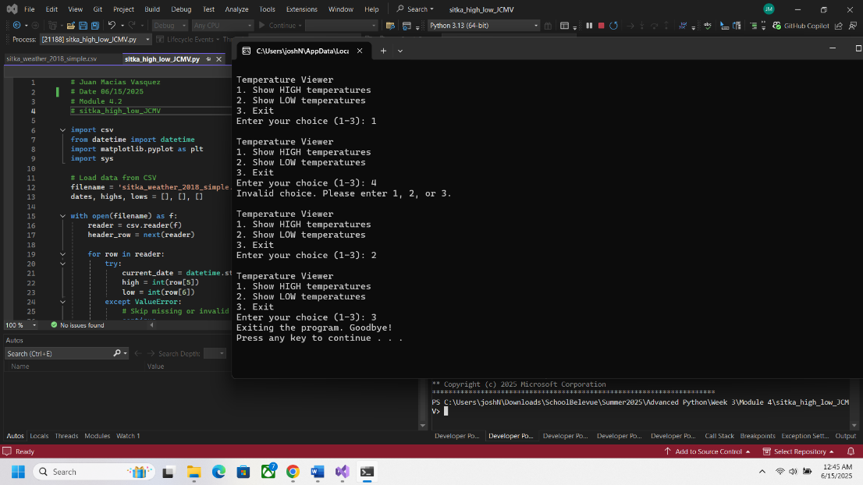

**New Flow Chart with Changes added**

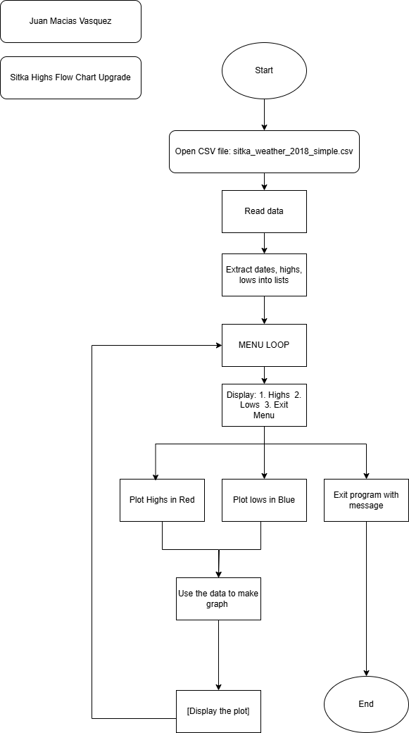

Flow Charts made in Draw.io